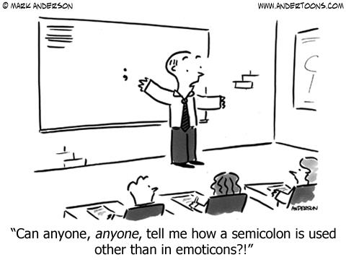

CP English 12
“That is part of the beauty of all literature. You discover that your longings are universal longings, that you're not lonely and isolated from anyone. You belong.” - F. Scott Fitzgerald

Course Description
Welcome to CP English 12! Our focus this school year will be learning and developing our skills as critical thinkers, readers, writers, speakers, and listeners. The development and mastery of these important literacy skills not only is important to achieving success in the Language Arts classroom, it is a critical component of achieving success in other school subjects, building strong relationships with others, and attaining a flourishing career as an adult. Basically, the quality of life you experience now thorough adulthood will depend a lot on how well you read, write, and communicate with others.

Positive Rewards for Following Rules
Your appropriate behavior in class assures everyone of an environment conducive to learning. Some possible rewards for continuous appropriate behavior are: intrinsic value (satisfaction of learning), improved skills, verbal praise, positive note to parents, tangible trinkets, and special class activities / privileges.

Class Rules
- Be respectful, compassionate, and understanding.
- Follow directions quickly.
- Take responsibility for your actions.
- Make smart
choices.

- Keep your dear
teacher HAPPY.

Class Expectations
- Be in seat when tardy bell rings.
- Put proper heading on all papers.
- Do not use electronic devices in class without teacher permission.
- Use restroom during passing breaks.
- Maintain a clean and orderly work area.
- Bring all of your supplies to class daily.
- Complete all of your work and turn it in on time.
- All school rules and policies shall be observed within the classroom.

Consequences for Breaking Rules
1. Warning: the teacher provides a verbal reprimand/reminder.
2. Lunch Detention: short time spent during lunch to contemplate conduct.
3. Detention: a mark recorded for poor conduct. Parent will be contacted.
4. Referral to Administration: immediately referred to administration for severe behavior problems.

Late Work
Late work will NOT be accepted for homework, VOCAB cards, worksheets, or in-class assignments. For essays and larger assignments there will be a ten percent deduction a day for a maximum of three days. Any points are better than none!

Progress Reports
Be sure you are checking ProgressBook throughout the year. Any questions/concerns should be brought up before or after school- not during class time.
Absence Protocol
Any class work, quizzes, or assigned homework that was due on a day when a student had an excused absence must be made up or turned in the next day of the student’s return to school. Please check the class “ABSENT WORK” tray for the assignments/quizzes. If the student has an unexcused absence it is a zero for the day- no exceptions.
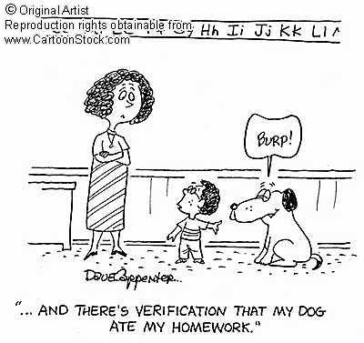
Readings
Readings for this class will be done both in and out of class. You will be encouraged to take notes over the readings. Quizzes over readings will be frequent and will cover basic concepts, literary elements, and ideas from the readings. Discussions will enhance our understanding of the reading material as we search for meaning and purpose. Exams or projects will complete many of our units.

Timed Writings
Timed writings are an on-going assessment of student writing and are practice for future process pieces and quarterly district writing benchmarks. Timed writings will be completed in class and considered assessments. These will help better prepare you for the ACT test and more.

Papers
Many, many papers will be written over the course of a year! These papers will range in length from single paragraphs to five paragraph themes. You will write to explain, inform, entertain, compare/contrast, analyze, and give opinion. Grades for your papers will be determined by content, style, organization, mechanics, creativity, proper format, and turning it in on time. All of your papers must be completed in the following format:
Your name
My name
Assignment name
Date submitted (in the top left corner of your paper).
Additionally, all formal papers must be double-spaced in Times New Roman, 12 point font and one-inch margins or written neatly in blue or black ink on non-perforated white paper.
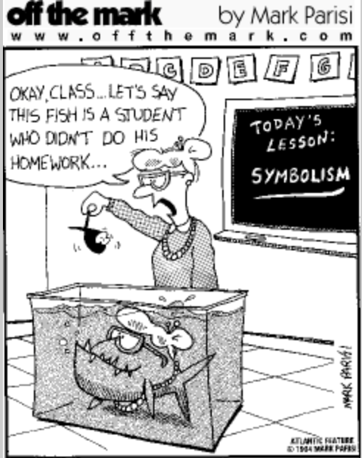
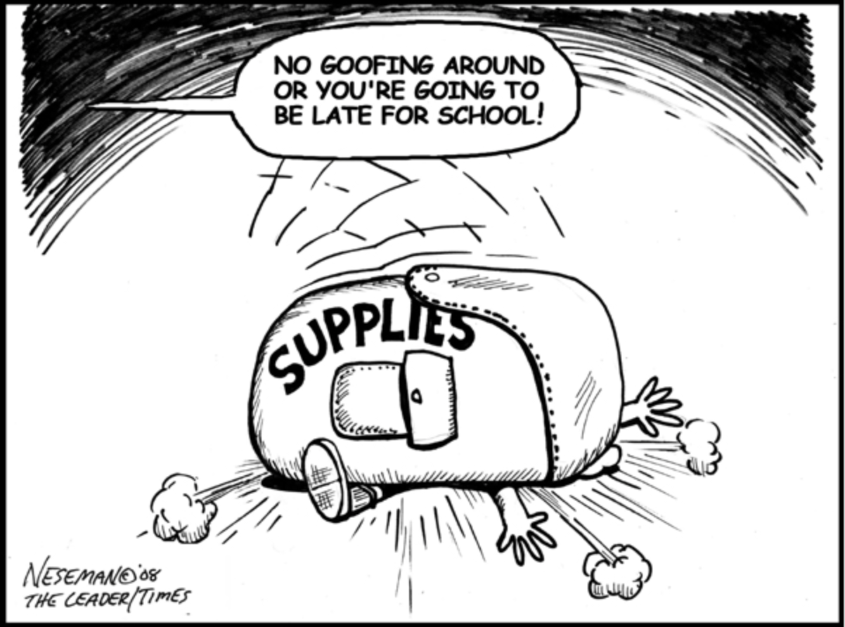

Grade Scale
A+ = 99%- 100% A = 95% - 98%
A- = 93% - 94% B+ = 91% - 92%
B = 87% - 90% B- = 85% - 86%
C+ = 83% - 84% C = 77% - 82%
C- = 75% - 76% D+ = 73% - 74%
D = 67% - 72% D- = 65% - 66%
F = 0% - 64%

Grade Breakdown
Homework/ Notecards = 10%

Asessments/ Quizzes = 40%

Tests/ Essays = 50%

Supplies
-Three Ring Binder (1in or larger)
-Five tab dividers
-College-ruled filler paper
-Two packs of 3x5 Index Cards
-Multiple pencils
-Highlighters
-Multiple colored pens
-Post-it Notes
*An additional ½ - 1in binder will be needed for college portfolio
- Page protectors
Objectives
This class will serve a number of educational purposes for you. Our main focus in this class will be on British Literature and research. We will continue to improve your reading and writing skills but with a more specific intent on preparing you for next year’s college courses. Vocabulary and grammar will also continue to be areas for improvement. This class is, by design, very intensive and should give you a somewhat realistic look at the college workload.
Students:
Please sign below to signify that you have read the course sheet for English 12 , will keep it in your folder, and will be responsible for the information throughout the year.

_______________________________ ________________________________
Student’s printed name Student’s signature

Parents/Guardians:
Please sign below to indicate that you have read the course sheet for English 12 and that you’ll help your student be accountable for the information. If you have questions about the course or your student’s work, please do not hesitate to contact me; email is the best way to reach me quickly. See the front of this sheet for my email address.

Please Read the course information, sign, and return this sheet to _Mrs. Kenworthy.

_______________________________
Parent/Guardian printed name

_____________________________________________
Parent/Guardian signature

_______________________________
Parent/Guardian e-mail
(please print)

______________________________________________
Parent/Guardian’s daytime phone number

Parents / guardians, please CIRCLE the best way for me to contact you (e-mail or phone)!

