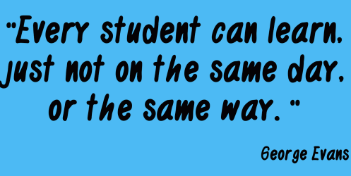

Get to Know Me… as a Student!

**Directions:** Read these directions carefully. This assignment is designed to get to know you as a person as well as a student. Take your time to read through and think about each question to answer it completely and honestly. Some questions may have several parts so be sure to take your time. Try to answer each question as best as you can. It may be beneficial to ask clarifying questions or underline parts of the question. Sometimes when you take a test you can be so concerned with the passage, time, or specific answers that we do not take enough time to read the directions. Reading directions completely is essential to take a test. When you take standardized tests and tests for any of your classes in high school you must make sure you understand what you are supposed to answer before you respond. So, if you are still reading these directions I commend you. That is a great start. I want you to begin taking this survey and answer the first five questions. Once you complete the first five questions put your pencil on your desk, stay seated, look ahead and wait silently. As the class finishes taking this survey we will go over your answers. Be patient and respectful while taking this survey.

1. What is your name and nicknames?
2. Do you like to read? Why or why not?
3. What is your favorite book? Why?

(If you don’t have a favorite book- what do you read…yes, twitter can count!)

1. How often do you write? It can be anything (journal, stories, quotes, grocery list?? :)
2. Do you enjoy writing? Why or why not?
3. What are your plans after high school? (at least 3 complete sentences)
4. Do you enjoy school? Why/Why not?
5. Do you participate in any extra-curricular activities? If so, what? (Include sports, clubs etc.)
6. Have you enjoyed English class in the past?   Why/Why not?
7. What is your favorite subject? Why?
8. What has been your favorite assignment in school? Why?
9. **What is one piece of advice you would give me for continuing my career as a teacher?**